#4 Delta
Special Instructions

Write Spanish Addresses Here

(North Side)

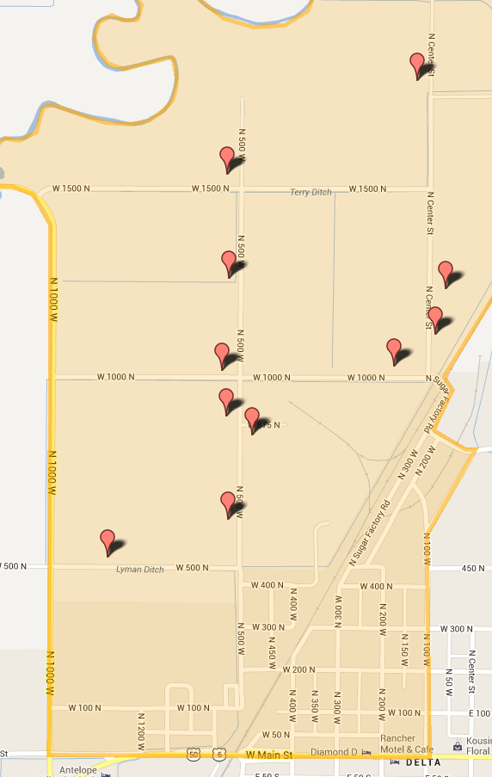
Work only the INSIDE of the boundaries unless map says otherwise.

